Titiel: Biogenic Dynamic Material Systems Model – bioDYM – biogenic carbon management and carbon cycle assessment

Introduction
Carbon is a fundamental element for natural and anthropogenic systems. It is unavoidable for nutrition, construction, energy and many other purposes. Biobased, fossil, mineral, gaseous or dissolved carbon forming the global carbon cycle, constantly transitioning between the large carbon stocks: Atmosphere, Lithosphere, hydrosphere and biosphere. The accumulation of carbon in the atmosphere is the major driver for climate change. To decrease the speed of this development, the objective of Carbon neutrality and net Zero until 2050 was formulated by the Paris Agreement in 2015(Source). This objective requires equal anthropogenic carbon output and input. Since the use of carbon remains foreseeable unavoidable, Carbon Dioxide Removal (CDR) approaches like Carbon Capturing and Utilization (CCU) or carbon capturing and storing (CCS) are becoming an important part of climate change mitigation strategies. At the same time photosynthesis is naturally extracting carbon from the atmosphere to form biomass as part of the biosphere. This can be exploited for the targeted sequestration of biogenic carbon by the application of biobased materials as a natural CDR strategy. However, effective and strategic carbon management requires considering the connections to the global carbon cycle as well as advanced tools to analyze large and complex systems in space and time.
Material Flow Analysis (MFA) is an established methodology for the analysis of environmental systems (Brunner & Rechberger, 2004). Various examples for the effective application of MFA for environmental systems are published (Muhayodin et al., 2021) (Fritze & Rotter, 2024). It is based on the law of conservation of mass and evaluates input and outputs of stocks and processes within a system defined in space and time. This makes the MFA a valuable carbon management tool, which can provide system evaluations and valuable insight into the quantity and the efficiency of biogenic carbon sequestration techniques. Carbon management is a long-term task, which shows its effects over long periods of time, and needs to consider dynamic changes in stocks and flows. The dynamic MFA (dMFA) allows modelling of dynamic systems over time and forecasting about effects of strategies and actions in the future. For example (Zhang et al., 2025) uses the dMFA methodology to present the development of bioplastics stocks and researches the amount of biogenic carbon within the build environment in Indonesia (Aryapratama & Pauliuk, 2019).
The high potential of dMFA to research complex environmental systems is hindered by the field of available solutions. Especially specific solutions for modeling biomass and biogenic carbon are lacking, due to specific natural processes with individual mechanics. Existing solutions either do not provide the required functionalities or require a higher level of knowledge e.g. in python. STAN 2.7 is a very established tool. Currently 360 articles cite STAN 2.7 in MFA studies within the context of several environmental studies. Even though the intuitive graphic user interface is helpful, the program lacks the ability to enter large data sets, the implementation of dynamic systems, modelling specific processes like the mineralization of biomass, and in data visualization. Tools, like sankeyMatic (source) and E-Sankey (source) are focused on the visualization of data, without providing the calculation infrastructure. With the publication of the python based framework for Open Dynamic Systems Modelling (ODYM), the analysis of dynamic systems became more practical (Pauliuk & Heeren, 2020). Various researchers used ODYM for dMFAs in the field of metals (add sources). To make use of the large set of functionalities, ODYM requires basic skills, in python coding, which is not yet standard in environmental sciences. In addition, it lacks adaptations, specific for biomasses.
To address this research gap, the study presents Biogenic Dynamic Material Systems Model – bioDYM, a python-based solution for dMFAs, as dynamic tool for biogenic carbon management. The development has a special focus on usability and accessibility, to support future studies in this field. BioDYM integrates specific processes and mechanisms for biobased materials, which are included in the conceptualization. With solutions for two complex case studies, the study presents the functionalities of bioDYM. Case study answers the question of the impact of the degradation of wheat straw to the carbon stock in the lithosphere. Case study 2 quantifies the contribution of wood as an anthropogenic carbon stock in the build environment.

Methodology
The presented research is built on several conceptual foundations, commonly used in the field of environmental sciences and industrial ecology. Thus 2.1 contains a summary of these important concepts. The listed concepts are integrated as a specific functionality into bioDYM. 2.2 explains its modular architecture and how the different parts are combined in a workflow. BioDYM is applied in two specific dMFA case studies to solve specific problems in carbon cycle assessment and to present the added possibilities of bioDYM. The Foundations for the case studies are presented in 2.3.

Conceptual Foundations
The Material Flow Analysis (MFA) forms a systematic and transparent methodology for investigating the material metabolism of natural and anthropogenic systems. Foundation of the methodology is the mass balance principle, which states the conservation of mass described by the equation: Input = Output + ∆Stock”. This can be applied at material, substance and element level. The MFA is designed as a methodology to determine the main sources, flows, stocks, and emissions of anthropogenic and natural materials. Process specific Transfer coefficients (TCs) determine the partitioning of material flows. The methodology was established by (Brunner & Rechberger, 2004) and forms the conceptual framework for dynamic MFAs in general and the foundation for BioDYM.
The dynamic MFA (dMFA) extends these principles from a static to a dynamic model by the additional dimension of time (Brunner & Rechberger, 2004). The time variable is introduced into the accounting process by the in-use stock and its lifetime distribution (Deng et al., 2023). Modelling age-cohorts specific material lifetime distributions is fundamental to describe the lifetime of products within the use phase (Pauliuk & Heeren, 2020).
Biomass incorporated in the soil forms a dynamic stock that decomposes over time due to the mineralization, a process caused by microorganisms (Robertson & Paul, 2000). The rate of decomposition is proportional to the amount of biomass and is described with the first order kinetics. To model C mineralization kinetics for complex biomasses, consisting of fast- and slow- decaying fractions, a two pooled approach was developed by (Cayuela et al., 2010). This mineralization principle of biogenic carbon is used by bioDYM to model carbon sequestration capabilities of systems, based on specific biomasses, with the implementation of the specific First Order Mineralization Process (FOMP).
A Monte Carlo (MC) simulation is a commonly used approach for addressing and quantifying the sensitivity of parameters and the uncertainty of a model. This is based on the definition of the uncertainty of selected parameters within different types of distributions (normal, uniform, triangular). The execution of the simulation includes a defined number of runs where in each run a random value for the defined parameters in the defined distribution is picked. This creates the full spectrum of possible outcomes and allows the identification of the most probable result, under the given assumptions. This also allows to detect parameters with a high sensitivity for the overall model (Papadopoulos & Yeung, 2001). The combination of uncertainty assessment and MFA is addressed by the Polymer-specific dynamic probabilistic material flow analysis (Abbasi et al., 2023; Kawecki et al., 2021). The high value of MC-Simulation for future MFA developments is highlighted by (Pauliuk & Heeren, 2020).

The BioDYM Tool: Architecture and Workflow
The Biogenic Dynamic Material Systems Model – bioDYM is an open-source Python model, built upon the ODYM Framework, which applies its principles for the description of systems, parameters, processes, stocks and flows (Pauliuk & Heeren, 2020). The application of ODYM functions and classes builds the logic foundation for the development of the modular software. The first version of BioDYM was published by (Lukas Hoppe, 2020). BioDYM is designed to enable the dMFA of biogenic carbon systems. The tool's operation follows a clear "Input-Process-Output" workflow, which can be conceptualized as a three-stage flowchart X. The workflow follows the general MFA Workflow from System Definition to model interpretation.

Figure 1: BioDYM Workflow

Step 1: System Definition & Data Import
System definition & data import of the MFA is exclusively done within the BioDYM Data Protocol (Biodym DP). It allows the structured system definition and the set-up of system boundaries based, for example on a developed system flow chart. The BioDYM DP is an excel file, which provides a robust data infrastructure for the model configuration and the input of all datapoints of the system. This approach intentionally separates the data layer from the calculation engine, which enhances model transparency and reproducibility. This allows also the use of Biodym, without advanced python knowledge, since the interaction with the code is not required. The bioDYM DP is structured into logical sections, where the system parameters are defined. Table X shows an overview about the sections of the bioDYM DP.
Table 1: Structure overview of the Biodym DP
Section | Content | Objective
0 | Model Configuration & System boundaries | General configuration of the model. Selectable are the time of the model, special processes, Monte Carlo simulation and Scenario Manager,
1 | Flows | Definition of flows and flow parameters (FM, WC, DM, CC). Definition of Flow Data Quantity.
2 | Processes | Definition of processes and input/ Output-Flows. Definition of process parameters (TC, Dyn TC, Stocks, Initial Stocks. Special Processes (FOMP, DSM)
3 | Special Processes | Definition of the DSM and FOMP parameters.
4 | Uncertainty Manager | Definition of uncertainty parameters as input for the Monte Carlo Simulation
5 | Scenario Manager | Definition of parameters to create additional scenarios for result comparison
A detailed guide is available within the SI of the study.

Step 2: Model Execution and Validation
BioDYMs calculation workflow consists of model execution and validation mechanisms. All elements are structured based on the execution order in a Jupyter Notebook, which acts as the user interface to start the calculation and to receive the model results and its visualizations. The only required manual user input is the definition of the file path of the BioDYM DP. The model execution loads the system configuration and the system parameters from the DP, initializes the model and executes the dMFA calculation. The system iterates through every year of the system, to calculate dynamic values for stocks and flows. Visual model validation provides a basic flow-chart of the system and a mass balance check. Violations of the mass balance principle are indicated specific to processes, elements and years. This allows the overall validation of the logic of the model and to identify errors in the data input.

Step 3: Results Visualization and Export
BioDYM contains a large variety of result visualization functions for the in-depth analysis of the system. All visualizations are interactive with widgets for the selection of specific processes, dynamic time sliders and export functions. A core feature is a dynamic Sankey Diagram, which provides a comprehensive system overview at any point in time. The provided visualizations of processes, flows and stocks support the interpretation of results. Uncertainties resulting from the Monte Carlo simulation are displayed, if selected. After the successful execution of the calculation, the results are exported as excel files.

Application of BioDYM for Carb
Two case studies about complex biogenic material systems demonstrate dynamic carbon cycle assessment with BioDYM. Basis for the carbon cycle assessment is the assumption that all components of the biogenic substances are received either from the Atmosphere (P0) or from the Environment (P1). The atmosphere is the major source for biogenic carbon, through the transformation of CO2 into biomass by photosynthesis. Every other component of the biomass is aggregated into a single environmental flow, originating in the environment, consisting mainly of water and other nutrients. Water and nutrients are part of the water and nutrient cycle. For the scope of the study, the atmosphere and the environment form stocks, with an unlimited supply of material. This assumption is justified with the focus on carbon flows, with the objective to model the carbon uptake of the system. Both case studies describe and present in detail the functionalities of bioDYM and are provided in the SI of the study.

Case Study 1: Carbon cycles within the wheat straw economy
Objective of case study 1 (CS1) is to analyze carbon cycles within the wheat straw economy. Specific objectives of CS 1 are:
- To quantify the annual and total carbon uptake from the atmosphere and the development of carbon stocks of the system based on dynamic input data.
- To evaluate the impact of a shift in technology over time with different treatment scenarios.
- To analyze first order mineralization processes and carbon uptake of the soil by composting rye straw.
- To identify most critical parameters influencing the system through a Monte Carlo simulation.
The system of CS 1 describes the entire lifecycle of wheat, starting with the raw material extraction, product manufacturing, use-phase and EoL-phase. The system is part of the global carbon cycle and includes the atmosphere and the lithosphere as global carbon stocks. The geographical scope is defined as a representative region in central Europe. The temporal boundary for the analysis covers 25 years, from 2025 to 2050, to incorporate future system dynamics based on historical data.
Described information about processes, flows and system boundaries are visible in Figure 1 System diagram for the wheat straw case study (CS1). Processes are shown as boxes, material flows as arrows, and the system boundary is delineated by the dashed line.
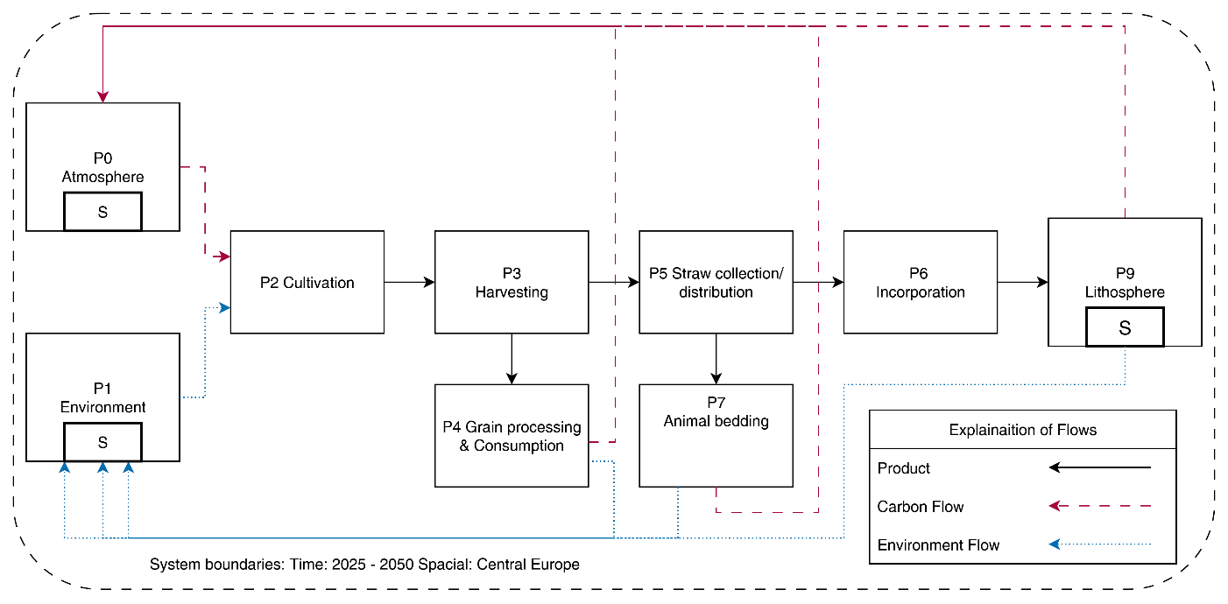
Figure 1: System diagram of CS1.
The model consists of 9 processes building one circular system. Every process is located within the system boundaries of the study and is connected with input and output flows with each other. This structure allows modelling cycles within the global carbon cycle. Table 1 contains an overview of all processes in the system, the process type and a description of the function. In addition, it is indicated, if an uncertainty is used for the MC simulation.
Table 2: Process List case study 1
ID | Name | Type | Uncertainty | Function
P0 | Atmosphere | Stock | No | Provides carbon for the cultivation of wheat.
P1 | Environment | Stock | No | Provides all other supplements & water for the cultivation of wheat
P2 | Cultivation | Process | No | Cultivation of wheat
P3 | Harvesting | Process; TC | No | Harvesting of wheat. Split of grains and straw
P4 | Grain processing & Consumption | Process; TC | No | Processing wheat grains and consumption of resulting food.
P5 | Straw collection/ distribution | Process (DynTC) | Yes (normal distribution) | Collection and distribution of wheat straw into several applications. Dynamic TCs model a shift in technology
P6 | Incorporation | Process | No | Direct incorporation of straw residues into agricultural soil.
P7 | Animal bedding | Process; TC | No | Use of straw as absorbent bedding material in livestock farming
P8 | Lithosphere | Stock; FOMP | Yes (normal distribution) | The soil as large carbon stock, including slow mineralization processes of carbon

Case study 1 is based on realistic data combined with assumptions with a highly explorative purpose. All flows are defined as product carbon or environmental flows. Each flow is treated as FM with the dimensions, WC, DM and CC. The detailed data sheets for CS 1 as well as the calculation model are available within the SI.
The quantity of harvested wheat is intended to describe a realistic scenario and the common best practice within the system boundaries. Straw input is material flow data about the annual yield (Yt) of wheat straw from 2025 -2050. Assumed is an agricultural area for wheat cultivation of 1.000km² (100.000 ha) in Germany. As a yield for winter wheat in Germany 7.7 Mg/ ha with an annual fluctuation of +- 1.0 Mg/ha are assumed (source). In addition, a long-term trend of 0.5% yield increase is included in the assumed flow.
$Y_{t}=Y_{trend,t}+∈_{t}$ (1)
$Y_{trend,t}=Y_{base}*(1+r_{trend}*\left(t-t_{0}\right))$ (2)
$∈_{t}\sim N(0,σ_{Y}^{2})$ (3)
Yt final calculated yield for year t
$Y_{trend,t}$ is the projected yield for year t based on a linear trend
$∈_{t}$ = is the random fluctuation for year t to simulate natural variability

Central for CS1 is the material composition of wheat straw at harvest status. The used data is based on laboratory experiments in combination with literature data. An overview of the material composition is visible in Table X.
Table 3: Material Composition assumptions Wheat Straw
 |  | Uncertainty parameters
Material Fraction | Value | Distribution type
Fresh mass (FM) | 100% | None
Water content (WC) | 14% | Triangular | Min= 10% | Max = 18%
Dry mass (DM) | 86% | none
Carbon Content of the DM | 48% | Normal | Mean= 48% | Std. dev. =1%
Carbon Content of FM |  | None

The study uses static and dynamic TCs to describe material behavior within the system. The TC of the Harvest (P3) is based on the grain / straw ratio of 53:47 (Source). The dynamic TCs for straw collection/ distribution (P5) are based on the currently technical used wheat straw in Germany of 74:26 (DBFZ). In P5 a shift of technology leads to an increase of the collection efficiency of 10% until 2050, which is modeled using dynamic TCs. All other TCs are based on illustrative assumptions detailed in the SI.
Incorporated wheat straw decays in the lithosphere and releases carbon emissions modelled by the two pooled FOMP process. Incoming biomass is split between the pools with distribution factors f1 and f2. 70 % enters the labile (fast decaying) and 30% enters the recalcitrant (slow decaying) pool based on (source). The decay rates for the labile (k1) and the recalcitrant (k2) are defined as k1= 0,5 yr^-1 and k2 = 0,025 yr^-1 (source).
The Monte Carlo Simulation is mainly used to research the impact of the straw distribution and collection and the FOMP Parameters on the model.
Scenario Set-UP (still missing)

Case Study 2: Carbon sequestration of Woody Biomass

Objectives:
Objective of case study 1 is the presentation of the following functions of bioDYM.
- Dynamic Input Modelling (DIM)
- Dynamic Stock Modelling (DSM).
- First Order decay modelling process (FOMP).
- Dynamic Transfercoefficients (DynTC).
- Monte Carlo Simulation (MC).

Application:
Case study 1 describes harvest, utilization and EoL treatment of wheat straw resulting from agricultural processes. Within this fictional case study, BiODYM is used to calculate carbon flows and to display carbon cycles. Specific objectives are the quantification of carbon uptake from the atmosphere of the system and the change of the anthropogenic carbon stock. The following functions are used to model complex interactions within the system: 1. DynTCs are used for the simulation of an shift in technologies and an increased efficiency. 2. DSM simulates the in-use stock within the system. 3. FOMP is used to simulate composting of rye straw within the soil. 4. A MC is used to simulate the sensitivity of the system.
is a dynamic MFA of pine Wood for the construction of roofs in residential buildings over a timeframe of 100 years from 1950 - 2050. Researched is the carbon flow originating in a fictional forest with an initial stock. Wood from the forest is processed and used in residential buildings. The DSM model is used to model different life times in the in-use stock of the wood. To simulate a shift in technology, an change in the efficiency of wood processing is assumed, which is displayed by dynamic tcs. After the use phase, the majority of wood enters the EoL displayed by incineration. The

Systemboundaries:
Case study 2 is located within the following system boundaries: The whole system is considered to be part of the global carbon cycle and includes the atmosphere and the lithosphere as carbon stocks. The study is located in middle Europe. A timeframe of 100 years, from 1950 until 2050 is used to display the dynamic capabilities of Biodym to combine historic data with forecasts. Within the anthropogenic interaction with the wheat the processes “farming”, “harvest”, “use-phase” and “EoL-phase” are modelled.

Processes and flows
Dies sind die Bausteine Ihres Modells.
ID | Name | Type | Uncertainty | Function
P0 | Atmosphere | Stock | No | Provides carbon for the cultivation of biomass.
P1 | Environment | Process (TC) | No | Provides all other supplements & water for the cultivation of biomass
P2 | Forestry | Process (TC) (Maybe Initial Stock?) Abnahme | No | Cultivation of woody biomass
P3 | Processing | Process (TC) | No | Processing of woody biomass
P4 | Incineration (BHKW) | Process (TC) | No | Incineration of woody biomass in internal BHKWs
P5 | Use-Phase | Process (DynTC) | Yes (normal distribution) | Use phase of wood in
P6 | EoL-Sorting | Process (TC) | No | Sorting of EoL Wood. Separation of wood for incineration, pyrolysis and recycling
P7 | Pyrolysis | Process (TC) | Yes (normal distribution) | Pyrolysis of EoL Wood and production of biochar
P8 | Incineration | Process (TC) | No | Incineration of EoL-Wood in a biomass incineration plant
P9 | Lithosphere | Stock; FOMP | Yes (normal distribution) | Incorporation of biochar in the soil and carbon sequestration in the soil
Table 4: List of flows in Case study 2

Results
BioDYM allows the dynamic material flow analysis of biogenic systems with the purpose of carbon cycle assessment. The application of BioDYM on two complex case-studies provides insights into the large potentials of applications.

Carbon cycles within the wheat straw economy
The incorporation of wheat straw leads to a constant inflow of biogenic carbon to the soil. This leads to an increase in biogenic carbon in the lithosphere, which is extracted from the atmosphere.
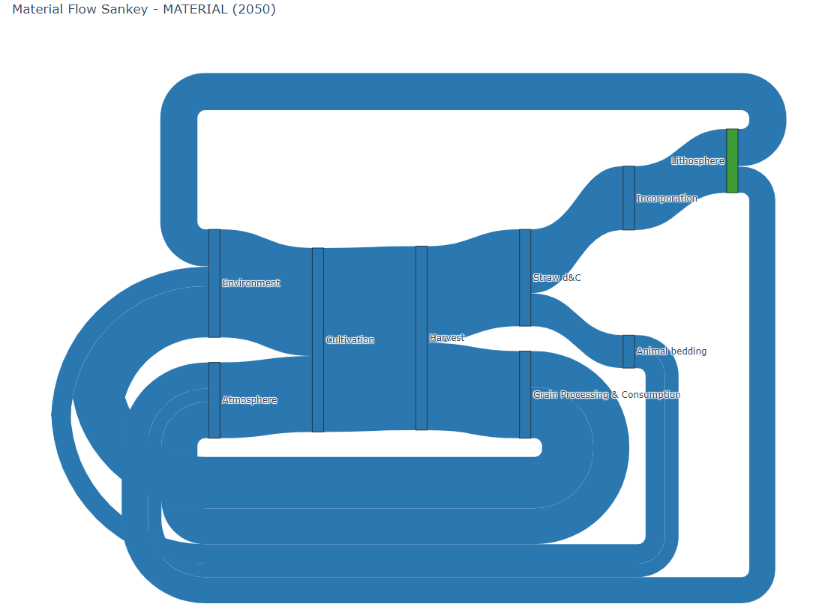 | 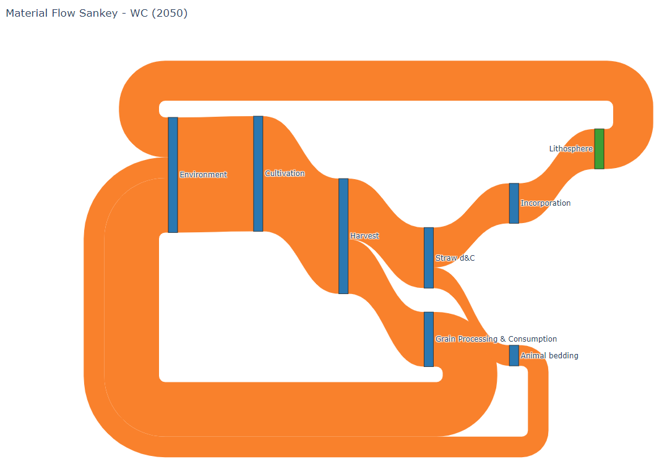
Dynamic Sankey Diagram of the material Flow in Year 2050. | Dynamic Sankey Diagram of the Water Flow in Year 2050.
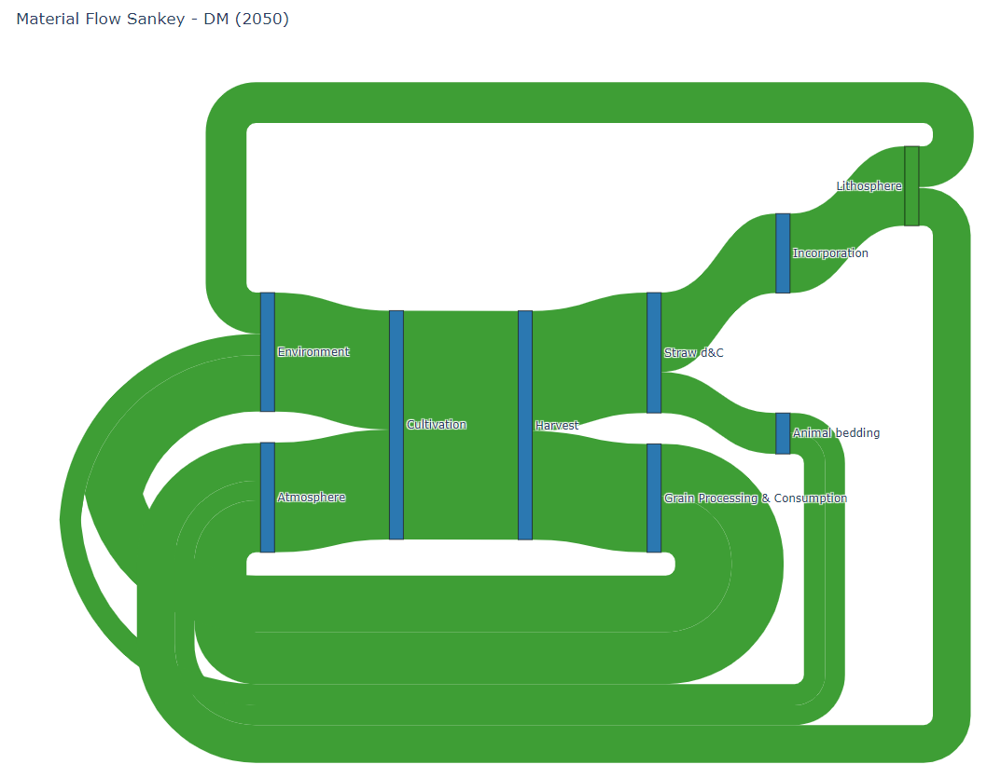 | 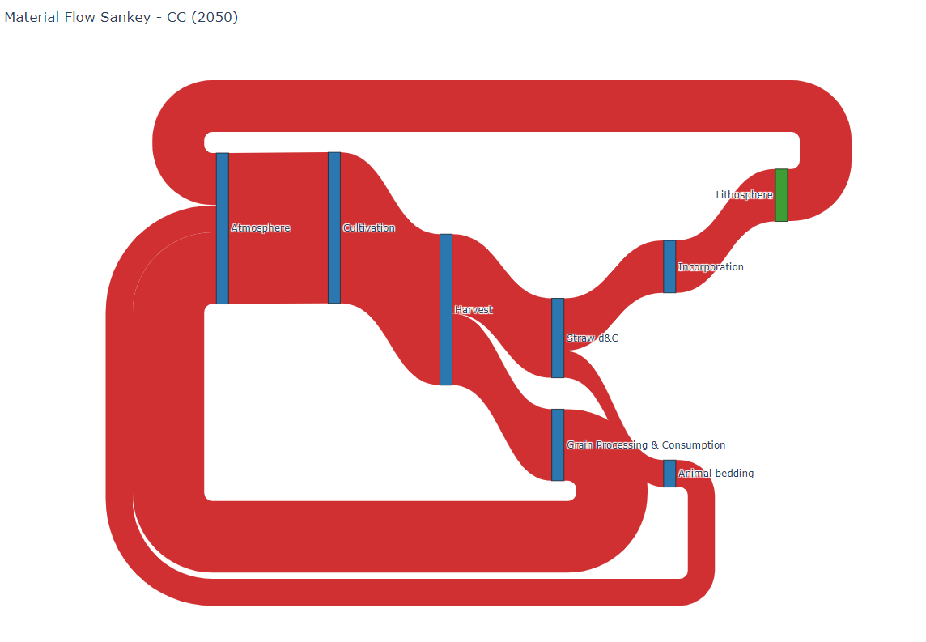
Dynamic Sankey Diagram of the dry mass flow in year 2050. | Dynamic Sankey Diagram of the carbon flow in year 2050.

• 3.1.1 Baseline Mass Balance (Highlighting the Sankey Diagram)
• 3.1.2 Dynamic Stock Evolution (Highlighting the time-series plots)
• 3.1.3 Scenario Analysis (Highlighting the DynTC feature)
• 3.1.4 Uncertainty and Sensitivity (Highlighting the MC and FOMP results)

Results case study 1

Results case study 2

Discussion

Added Value of bioDYM to the ODYM Framework

Further Development

Conclusion

- System definition:
  - Multielement MFA analysis
- Calculation
  - Dynamic/ static material input
  - Dynamic/ static Transfer coefficients
  - Initial Stocks
  - Dynamic Stock Modelling
  - First Order decay process modelling
  - Scenario comparison (TC Change)
- Visualization
  - System Visualization
Dynamic Stock Modelling | DSM
First Order Process Modelling | FOMP
Dynamic TCs | DynTCs
Initial Stock | InitS
Monte Carlo Simulation | MC

Objective of the study is the application of the ODYM Framework for the development of the bioDYM framework, that fullfilles the following requirements:
- Specific for the requirements of biomass: Freshmass, WC, Drymass,
- Dynamic stock modelling. Individual life times within the use phase
- First Order Decay of biomaterials
- Dynamic Sankey diagrams, Stock modelling
- Increased Usability. Protocols, Data management: Carbon Cycles
- Monte Carlo Simulation to
- The model_configuration allows the set-up of all major settings and system boundaries of bioDYM. The selectable is the timeframe, the selection of special processes and the use and the size of a monte Carlo simulation. A scenario manager allows to set up scenarios for result comparison.
- The “1_1_Definition_Flows” introduces all flows of the model and connects them with input and output processes. In addition, the flow properties of water content (WC), Dry mass (DM), and Carbon Content (CC) are defined here. “1_2_Data_Flows” is intended to enter specific flow data for specific flows in defined years. The selection of the year of the flow is key for the dynamic material flow calculation.
- “2_1_Definition_Processes” has the objective to define the processes of the model including the process properties. These properties define the process type (Input/ process/ output), the use of Transfer coefficient & Dynamic Transfer coefficient, the presence of an stock or an initial stock and initialize the special processes Dynamic Stock Modelling and FOMP. The individual properties are defined in the pages 2_3_Process_TCs, 2_4_Initial_Stock and 2_5_dynamic_tcs.

Special Processes
The protocol applies several data management principles, data validation routines and color guiding system, as an assistance to lower the entry level of the application.

able X contains an overview about the main workflow of the BioDYM execution and the designed calculation engine. The four steps describe the main workflow and the basis for the system architecture. As practical user interface, a Jupiter notebook was selected. Each step contains a separated engine including a testing section, proving the functionality of the part.

Setup and Data Loading
To ensure the expected high usability of Biodym, the setup and data loading process is limited to the selection of the data upload path of the Biodym-DP in the Biodym-NB. With the initialization of bioDYM, the required packages and functions are loaded and initialized. All study-related parameters like model configuration, flows, processes, are loaded from the excel file, saved as variables and are used for the model calculation in step 2. The settings within the model configuration decide which specific calculations are executed.

Calculation & Validation
The calculation engine contains the relevant calculation functions for the standard processes as well as the special processes, including the monte carlo calculation and the scenario calculation. To allow the data validation, the model provides a simple qualitative flow diagram and an dynamic mass balance check, for all elemental layers.

